Round 1 Picture Quiz
All these songs have been played by Snake at least once in his Live streams on YouTube.
Can you identify the song titles from the picture clues?

1 2 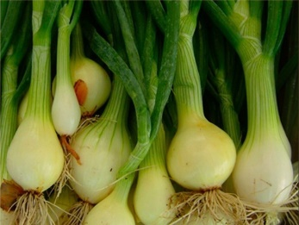 3 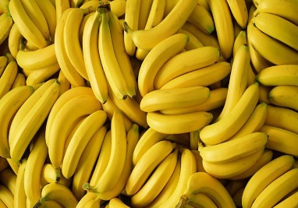
At Dawn Green Onions Bananas
- 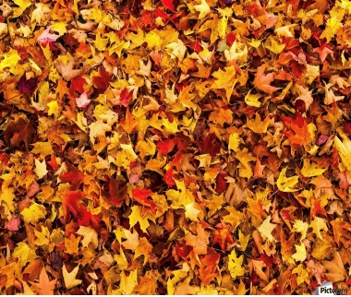 5 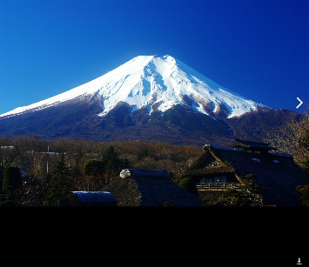 6 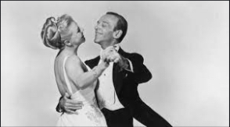
Autumn Leaves Fuji Sighting Cheek To Cheek
7 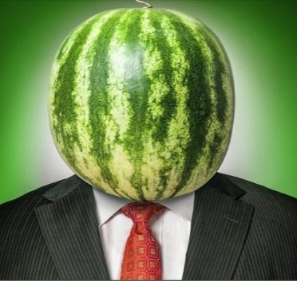 8 9 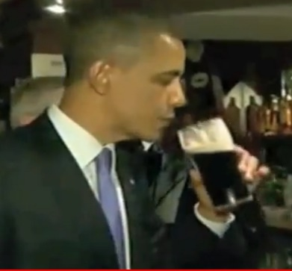
Watermelon Man The Night Train The Shannon Pint ( Barack
Obama arrives at Shannon Airport)
10 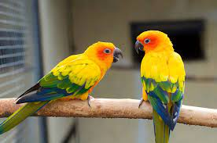
Talking Bird

